

**Mawlana Bhashani Science and Technology University**

***Santosh, Tangail-1900***

**Project Report**

**Department: Computer Science and Engineering**

**Course Title: Software Development Project-I and Industrial tour**

**Course Code: CSE2112**

**Submitted by**

Name: Homiya Nowshin Ananna

ID: CE20058

2nd year 1st semester

Session: 2019-20

**Supervised by**

Mohd. Sultan Ahammad

Assistant Professor

Department of CSE, MBSTU.

**Submission Date:** 12th October 2022

**Project Title: Console Based Offline Dictionary**

**Table of Contents:**

Page no.

Introduction………………………………………………………… 1

Motivation………………………………………………………….. 1

Objectives…………………………………………………………... 2

Project Requirements……………………………………………….. 2

Benefits…..….……………………………………………………… 2

Features……………………………………………………………... 3

Functionalities……………………………………………………..... 3

Snapshots and how to use……………………….…………………. 4-6

Limitations…………………………………………………………... 7

Future Possibilities………………………………………….…...…... 7

Conclusion……………………………………………….…………... 7

References……………………………………….…………………... 8

GitHub Link…………………………………………………………. 8

**Introduction:**

Offline dictionary is exactly what its name suggests, a dictionary that you don’t need an internet connection to use. Dictionaries are used to solve user’s vocabulary confusion or problem. Just few clicks and the meaning is known.

Here I’ve used C programming language to build up this console based offline dictionary. I’ve also used a special console to execute the program. This project takes words as input from the user and shows the meaning of that word according to users’ choice.

The approach is to use two separate text files where meaning with respective words are available and the program will take input and search for a match in those files to retrieve appropriate meaning and show as output. The app targets any type of computer user who ever finds a word which meaning is not known to him/her.

**Motivation:**

A good dictionary is an essential tool for any language learner. It can help you understand meanings of words better, improve your level of communication and improve your grades by making sure you are using words correctly. Since there’s no need of internet connection, you can use an offline dictionary to look up the meaning of any words that you don’t understand anytime from anywhere, such as when you’re on a plane, traveling abroad, out of cellular tower or if you want to save battery.

Also, it enriches one’s vocabulary and easily portable. While studying and working in different levels, we, students frequently come across inconveniences with Engineering vocabulary. So, I thought of designing a software which is user friendly and flexible. This Dictionary serves the purpose, I presume. I’ve finished here, but my vision is to expand this project further.

**Objectives:**

* The main objective of this project is to implement an offline English/Bengali dictionary to find the meaning of English to Bengali words and vice versa from any place in the world.
* The dictionary will be user friendly so that any person with a basic knowledge can access it.
* It will solve the problems faced by English or Bengali language learners.

**Project requirement:**

* ***Software requirement:***
  + **Platform:** Linux
  + **IDE:** Code::blocks
  + **Terminal:** Konsole
  + **Keyboard:** Avro or Open keyboard
  + Notepad
* ***Hardware requirement:***
* A PC with Linux operating system
* Mouse, Keyboard.

**Benefits:**

* Easy to find out the meaning of a word.
* To make the program flexible, there is an option to add new words and their meanings.
* Very simple and easy to handle for the user.

**Features:**

1. **Meaning:** The most important information about a word that a dictionary contains is the *meaning*.
2. **Spelling:** English spelling can be a very difficult area even for those whose first language is English. This is also true for Bengali language. A dictionary will obviously be useful in checking the spelling of words, which is important.
3. **Adding:** To enrich the usage of this dictionary there’s an option to add word. User can add new words as they learn.

**Functionalities:**

* This is a simple dictionary project. At first, I’ve opened a welcome page and asked which dictionary the user wants to choose. After that I’ve shown a menu page to perform some actions as to search a word, add words
* Then I’ve used the inner separate frames – each of which contains text fields according to their functions.
* For writing, I’ve use add_word function.
* For reading, I’ve used search_word function.
* I’ve used line by line checking procedure. For each input there will be a unique output line. While adding a word if the output is more than one line and as it is saved in the output file then the input and output will mismatch. So, I humbly suggest you avoid any output that could be more than one line.

**Snapshots and how to use:**

* 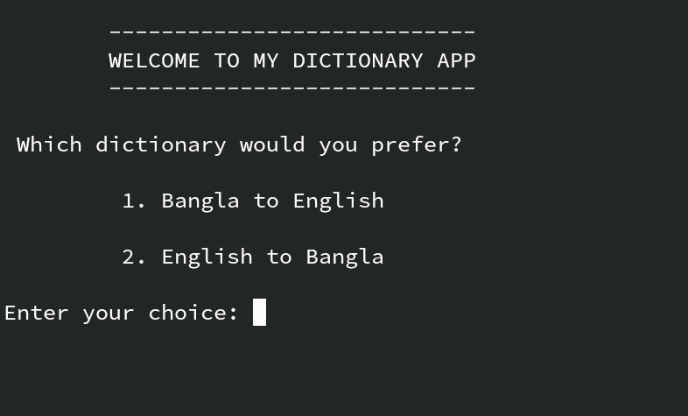***Snapshot of homepage***

The image here shows the home page. Here a greeting message is shown and below the greeting message there’s a section where user must choose the dictionary, he/she would like to use.

Press 1 to choose Bangla to English dictionary and press 2 to choose English to Bangla dictionary.

* ***Snapshot of menu page***

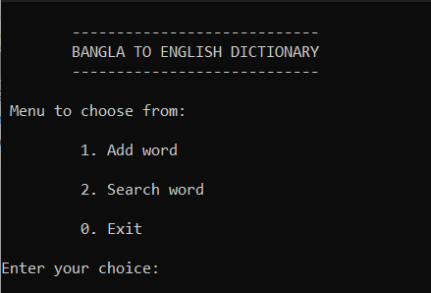

**(**Image 1)

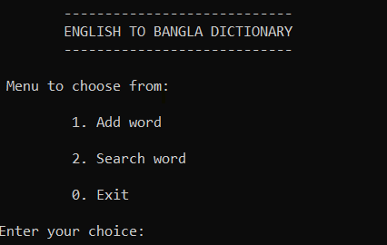

(Image 2)

By pressing 1 user has chosen to work with Bangla-English dictionary (image 1). But if user has pressed 2 instead of 1 then he/she chose to work with English-Bangla dictionary (image 2).

In both images a menu with 3 options is shown. Options include add word, search word and exit. Each options containing different functions as their name suggests.

Users can choose any of the options give as he/she desires.

* 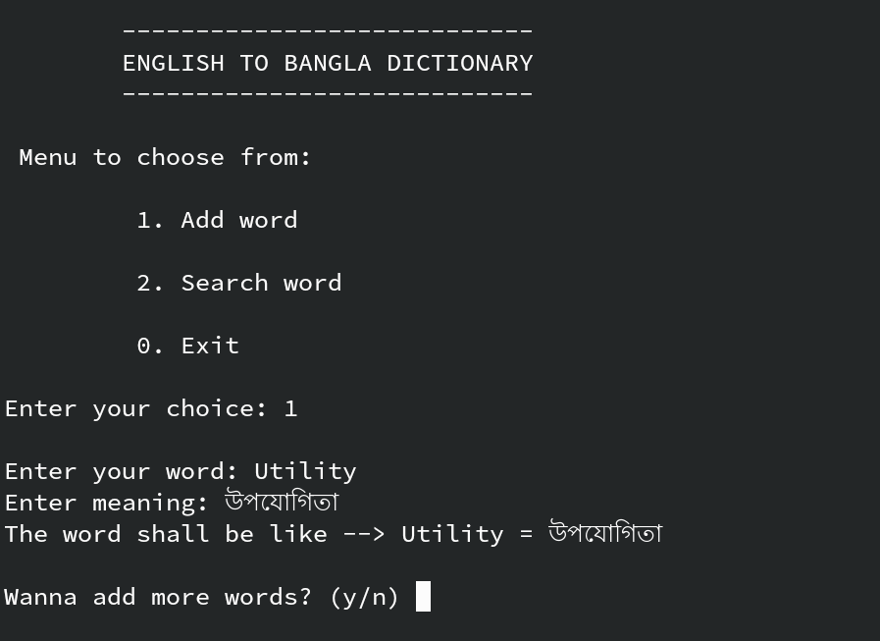***Snapshot of adding word***

Suppose the user chose 1, it would mean the user wants to add word to the dictionary.

To add a word the user is asked for the word and the meaning of that word. There’s scope to add more than one word if the user wants to.

Here image 1 shows a demo to add a word such as utility in the dictionary and the word has been successfully added.

If user doesn’t want to add anymore words, then the programs go to the options page.

* ***Snapshot of options page***

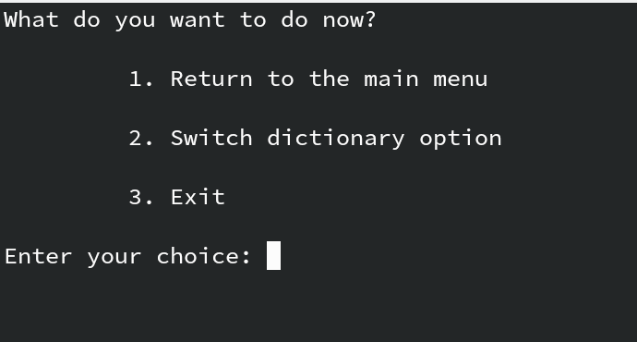

In this section, the user enters an option of which the user wants to do such as to return to the main menu, switch between dictionary or to exit from the application.

**Limitations:**

1. This application is based on C language. The major limitation of this application is the size of the SSD card that the PC is using.
2. Currently this application cannot display the parts of speech of the word you are seeing.
3. This application can currently show only the meaning of words that has been input. But it cannot translate a whole sentence.

**Future possibilities:**

* Making it as an android application,
* Adding graphics to it,
* Language extensibility,
* Parts of speech recognition,
* Sentence translation.

**Conclusion:**

The proposed system helps to access English word input and Bengali word output also vice versa. The easy understandability and usability of the application makes it better. This project gives a new experience where the word is easily detected by the application and gives the output very fast.

This project is still in a very early stage. There’s scope for improvement and much potential to nurture. I’ll try to add more features to it and overcome the limitations in near future.

**References:**

* Bangla-English Academy Dictionary
* English-Bangla Academy Dictionary
* Google
* GitHub
* Stack Overflow
* YouTube
* Wikipedia

**GitHub link:**

<https://github.com/Nyctophilia58/Project--2-1-/tree/main/Dictionary>

---------------------------------

Signature of the supervisor